**Blockchain in Healthcare: Paving the Way for Secure, Transparent, and Patient-Centric Care**

**Introduction**

Imagine a future in which your healthcare history is automatically available to any licensed physician but completely impervious to hacking and illicit entry. Imagine insurance claims processing instantly, less fraud and fewer administrative hassles. This isn't a futuristic dream—it's what the future looks like under blockchain technology and medicine.

Initially developed as the backbone for cryptocurrencies such as Bitcoin, blockchain has matured into a mighty utility for safeguarding and handling sensitive information. In medicine, it promises to transform patient files, drug tracking, clinical trials, and billing systems, all under the garb of maintaining confidentiality, transparency, and efficiency.

But how is blockchain actually utilized in healthcare, exactly? What are its actual applications, and what obstacles must we overcome before we can effectively integrate it into medical systems? This chapter looks at these questions, providing a close-up analysis of how blockchain is revolutionizing healthcare.

**Understanding Blockchain Technology**

**What Is Blockchain?**

In simplest terms, blockchain is a distributed digital ledger that stores transactions on many computers so that they are secure, transparent, and immutable. Every "**block**" of data (e.g., medical history, drug shipments, insurance claims) cannot be modified after being added to the "**chain**" without agreement from the network.

**Key Features of Blockchain in Healthcare**

1. **Decentralization –** Nobody owns the data, lowering manipulation risks.
2. **Immutability –** Data cannot be altered once it has been recorded, providing integrity.
3. **Transparency –** All parties with authorization can confirm transactions.
4. **Security –** Sensitive patient information is encrypted using cryptography.

These characteristics make blockchain perfect for healthcare, where data breaches, interoperability problems, and inefficiencies afflict existing systems.

**Applications of Blockchain in Healthcare**

**1. Electronic Health Records (EHRs) Management**

The biggest obstacle in medicine is fragmented medical records. Clinics, hospitals, and specialists sometimes have varied systems of electronic healthcare records, causing smooth information interchange to become impractical.

**EHRs utilizing blockchain rectify this through:**

* Granting ownership of information over to patients concerning who uses the data.
* Supporting up-to-date updates everywhere for approved practitioners.
* Shielding medical histories against unauthorized changes.

**Example:** MIT's MedRec utilizes blockchain in developing an EHR system from a patient-first perspective to enabling secure data interchange while still holding information as personal (Nguyen, 2023).

**2. Pharmaceutical Supply Chain Security**

Counterfeit medication costs the world economy more than $200 billion each year (CoinLaw, 2025). Blockchain can trace the path of a drug from the manufacturer to the patient, confirming authenticity.

**How it works:**  
• Each batch of drugs receives an individual digital ID written on the blockchain.  
• Every transaction (production, shipping, dispensing) is tracked.  
• Patients and pharmacists can check drug authenticity through blockchain records.

**Example:** Companies such as Chronicled and Modum utilize blockchain to fight counterfeit medicines.

**3. Clinical Trials and Medical Research**

Manipulated or phony clinical trial results discredit medical progress. Blockchain provides transparency and integrity by:

* Documenting trial protocols, patient consent, and results unalterably.
* Preventing selective reporting of positive results.
* Enabling real-time audits by regulators.

**Example:** The FDA has investigated blockchain to automate clinical trial data validation (Zhang et al., 2021).

**4. Smart Contracts for Insurance and Billing**

Medical billing is famously sluggish and prone to errors. Smart contracts—automated agreements on blockchain—can do:

* Insurance claims processing (immediate verification and payment).
* Fraud detection (duplicate claim flagging).
* Patient billing (payment and reminder automation).

Example: Estonia's eHealth platform employs blockchain technology to minimize administrative delays (Taherdoost, 2023).

**Benefits of Blockchain in Healthcare**

| **Benefit** | **Impact** |
| --- | --- |
| **Enhanced Security** | Reduces data breaches with encryption and decentralization. |
| **Improved Interoperability** | Seamless data sharing across hospitals, labs, and insurers. |
| **Patient Empowerment** | Patients control who accesses their medical data. |
| **Cost Efficiency** | Reduces administrative waste and fraud. |
| **Trust in Clinical Data** | Ensures research integrity and drug authenticity. |

**Challenges and Considerations**

Although promising, blockchain adoption in healthcare is challenged:

1. **Regulatory Compliance** – Needs to comply with HIPAA (US), GDPR (EU), and other privacy regulations.
2. **Scalability Issues –** Blockchain networks become slow with large volumes of transactions.
3. **Integration with Legacy Systems** – Hospitals have legacy IT systems that might not be compatible with blockchain.
4. **Data Standardization** – Various EHR formats make interoperability challenging.

**Solution:** Hybrid blockchain models and government-industry partnerships (e.g., Estonia's national eHealth system) are promising.

**Real-World Case Studies**

**1. Estonia’s Blockchain-Based eHealth System**

Estonia, a pioneer in digital governance, applies blockchain to:

* Store 1.3 million patient health records securely.
* Enable citizens to manage access to their medical information.
* Automate tracking of prescriptions to avoid fraud.

**2. IBM Watson Health & FDA’s Blockchain Pilot**

IBM partnered with the FDA to explore blockchain for:

* **Secure patient data exchange**.
* **Tracking opioid prescriptions** to combat abuse.

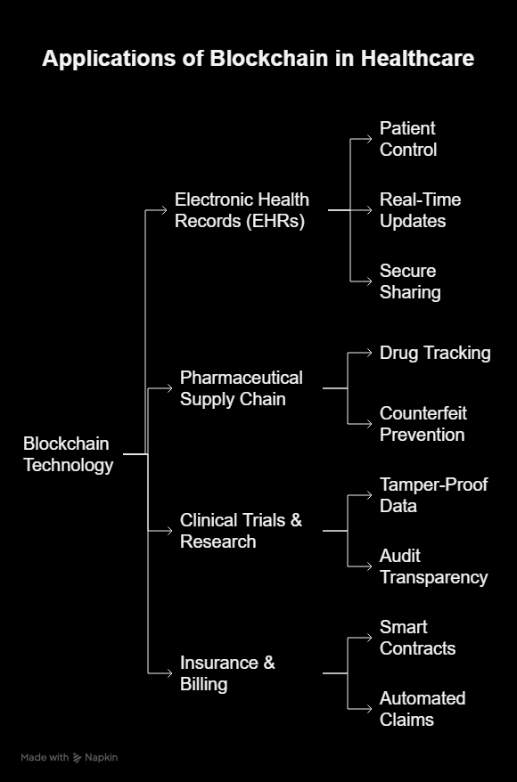

**Future Outlook**

Healthcare blockchain is currently in its infancy, but indications are that:

* Wider adoption of decentralized EHRs by 2030.
* AI-blockchain integration for prescriptive healthcare analytics.
* Global standardization processes for medical information.

As privacy fears intensify and cyberattacks multiply, blockchain's part in securing medical information will only continue to grow.

**Conclusion**

Blockchain is not a fad—it's a revolutionizing power in healthcare. From secure patient records to fraud-immune drug supply chains, its uses are enormous. Although challenges such as scalability and regulation exist, continuing innovations and pilot programs are laying the groundwork for a more transparent, efficient, and patient-centered healthcare system.

The future of healthcare is patient-controlled, secure, and decentralized—and blockchain is at the forefront.

**References**

* Nguyen, A. M. (2023). *Challenges of Blockchain Applications in Digital Health: A Systematic Review*. arXiv preprint arXiv:2304.04101.
* Taherdoost, H. (2023). *Privacy and Security of Blockchain in Healthcare: Applications, Challenges, and Future Perspectives*. *Sci*, 5(4), 41.
* Zhang, R., Xue, R., & Liu, L. (2021). *Security and Privacy for Healthcare Blockchains*. arXiv preprint arXiv:2106.06136.
* CoinLaw. (2025). *Blockchain in Healthcare Finance Statistics 2025*. Retrieved from <https://coinlaw.io/>
* Springer. (2024). *A systematic review of privacy-preserving blockchain applications in healthcare*. *Multimedia Tools and Applications*.